Teacher Guide:
Wet Chemical Etching of Silicon

Module Description: Students will use the photo-assisted etching of p-type silicon with potassium hydroxide solution to study principles of electronics manufacturing and chemical kinetics.

Learning Objectives:
After completing the activity, students will be able to describe the role of wet-chemical etching in semiconductor manufacturing.

After completing the activity, students will be able to describe the promotion of electrons in the band-gap region of p-type and n-type silicon.

After completing the activity, students will be able to analyze the effects of environmental variables on the rate of a chemical reaction.

Alignment with Next Generation Science Standards (NGSS)
If used, this module should be used in the context of the NGSS Standards: HS-PS1 Matter and Its Interactions, HS-PS2 Motion and Stability: Forces and Interactions, and HS-PS3 Energy that possess their own crosscutting concepts.

Target Grade Level(s)
This module could be used in an “honors” introductory chemistry class (grades 10-11) or an Advanced Placement Chemistry course (grades 11-12).

Prerequisite Knowledge/Skills
For this module, students need laboratory skills necessary to safely set up and perform a chemical experiment involving a strong alkali solution and a DC electrical circuit.

For this module, students need an understanding of the principles of chemical kinetics and collision theory, including the effect of solution concentration, temperature, and other factors on the rate of a chemical reaction.

Background
Patterning of semiconductors is fundamental to the production of electronic devices and integrated circuits. Patterning can involve both additive and subtractive processes. Wet chemical etching is a common subtractive technique. In wet chemical etching, a semiconductor is placed in a solution of a chemical that reacts with the surface of the wafer, removing material from the wafer by forming soluble products.
Making a patterned etch is usually accomplished by covering the portion of the sample that is not to be etched using patterned photoresist or if need be, a more robust material. This process can involve many expensive and time-consuming steps.

If the reaction is sensitive to light, an illumination pattern can be used to generate a patterned etch resulting in a much faster and cheaper process. Edwards et. al., have successfully patterned gallium arsenide (GaAs) using a hydrogen peroxide and phosphoric acid etch and illuminating with a PowerPoint™ slide projected onto the sample. See Fig. 1.

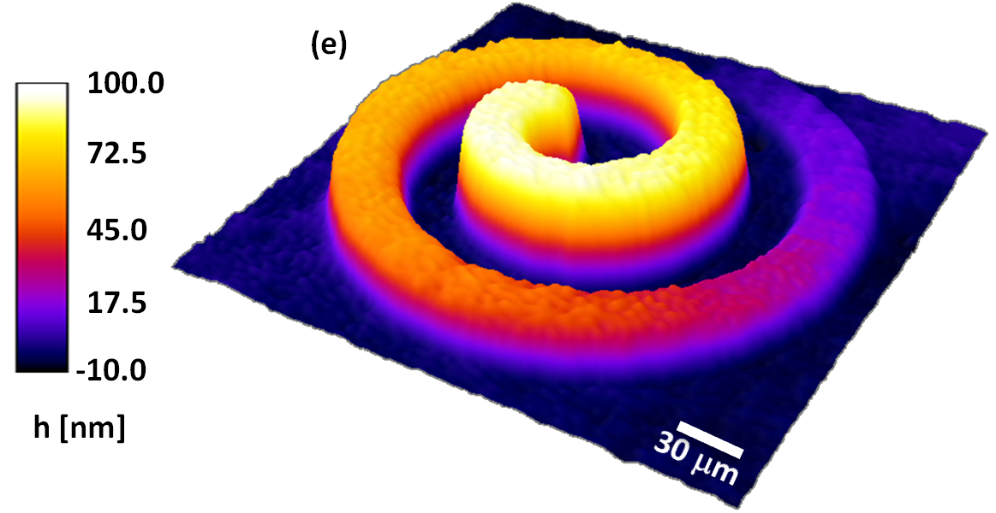
Figure 1: Etched Archimedean Spiral

Chemistry:
Wet chemical etching typically follows a two-step oxidation/reduction mechanism in which an oxide is formed and then dissolved or stripped away. Etch rates are dependent on the kinetics of the reaction.

The Chemical Reaction⁴:
Oxidation step
Si + 2 OH⁻ Si(OH)₂²⁺ + 4e⁻
Reduction step
4H₂O + 4e⁻ 4OH⁻ + 2 H₂
Overall reaction
Si + 4H₂O Si(OH)₂²⁺ + 2H₂ + 2OH⁻

Theory:
In p-type silicon, free electrons are the minority carriers and holes are the majority carriers. This means the reduction step, which needs electrons, will likely limit the reaction. Semiconductors have a “band gap” which is the energy required to promote an electron from the valence band, where it is localized in a bond, to the conduction band. If the band gap is direct, the electrons will more quickly relax back to the valence band. Silicon’s indirect band gap allows electrons promoted to the conduction band to remain longer and even diffuse away from the location where it was generated. Raising the temperature, and illuminating the silicon can work in combination to generate free electrons in the silicon that can migrate to the surface and supply electrons for the reduction step. The formation of robust oxides that can passivate the surface and slow etching is avoided by using cathodic bias, charging the silicon negatively. According to ³Starosvetsky et. al., the right conditions can result in an illuminated etch rate that is 25 times greater than the dark etch rate. Light projected onto the surface can thus allow an image to be etched into the surface.

Parameters Optimized:
-Etchant-(13:6:1 H₂O/KOH/C₃H₇OH shows some selectivity).
-Temperature-50ºC on a hot plate gives a faster etch.
-Type of silicon-(100) p-type (Resistivity = 6.3-8.5 W . cm) gives
good illumination selectivity.³
-Bias-Cathodic bias (about -55V) gives a fast etch with good
selectivity.³

Results:
Using the parameters shown above and the simplified setup below Fig. 2, images were successfully etched into silicon Fig. 3. The formation of hydrogen bubbles diffuses the light beam, limiting the resolution of the
etched image, but highlighting the illuminated image on the sample during etching Fig. 4.

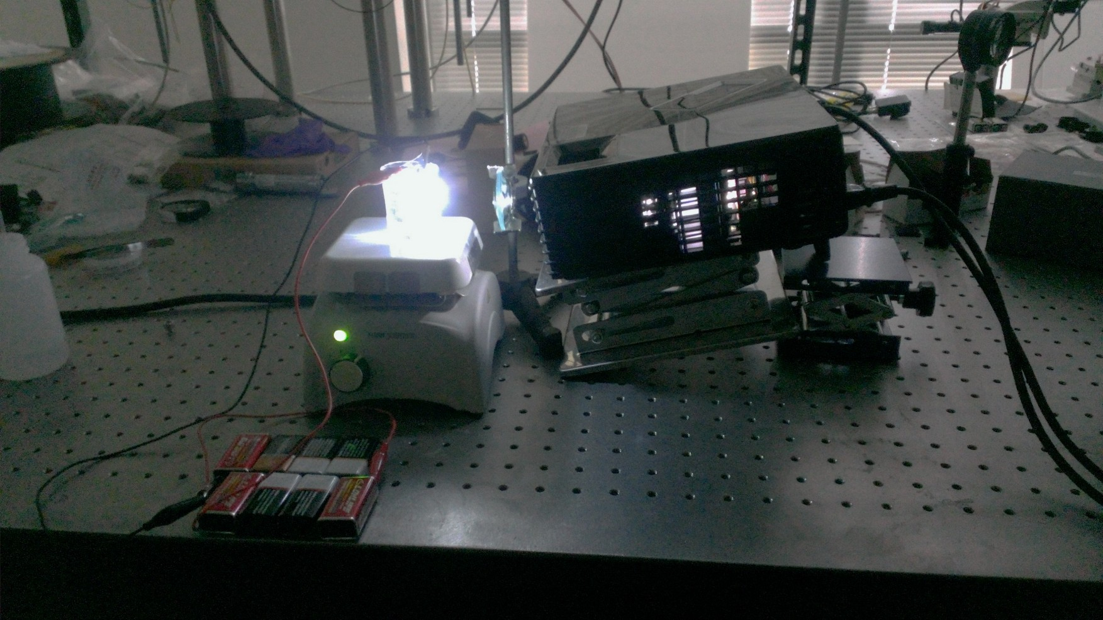
Figure 2 PECEP setup
Figure 3: Etch

Figure 4: Illumination

Duration
This module requires one week (5 class periods) for complete implementation.

Preparation time
Materials will need to be ordered sufficiently in advance to assure all needed items are present at the start of the unit. Some items are not available in a typical science storeroom. The materials require less than an hour to set up once acquired.

Preparation Notes
The suggested etchant mixture for this experiment is approximately 5.0 M KOH and 1.0 M isopropanol (C₃H₇OH) in water. A water: potassium hydroxide: isopropanol mass ratio of 13:6:1 has shown good results in preliminary tests. However, in the interest of guided inquiry, students should be encouraged to vary the etchant ratio as well as other parameters in order to optimize the etching results. The chemicals should be mixed in a flask on a stir plate.

Safety
Protective wear including chemical splash goggles, an apron, and chemical resistant gloves will be needed by students handling the caustic potassium hydroxide etching solution since it is corrosive to the skin. In the undiluted state, isopropanol is flammable and should be kept away from sparks and open flames.

Waste Disposal
Used etching solution should be flushed down the drain with copious amounts of water. The etched silicon is nonhazardous and may be kept by the students (make it-take it), or disposed of in a trash can.

Materials/Supplies/Equipment
Each group setup will need the following materials.

Video projector (high brightness and resolution works best)
Example: Epson VS230, SVGA, 2800 Lumens Color Brightness (color
light output), 2800 Lumens White Brightness, 3LCD Projector-$333.99
on Amazon.com
Ring stand-Flinn Scientific Company-AP4550 $10.75
single jaw buret clamp-Flinn-AP1034 $11.80
Optical Glass Lens Set-3 Dbl Convex, 3 Dbl Concave, 75mm Diameter, 20, 30, 50 cm focal length-$19.76 on Amazon.com
Hot plate-Flinn-AP7233 $177.15
100 mL beaker-Flinn GP1010 $3.25
150 mm, SSP p-type silicon wafer – University Wafer – ID 2087 $19.90 each or comparable.
9 V batteries (6-10 per setup)-Flinn Scientific Company-AP 1430 $4.95 each
Alligator cords-Flinn Scientific Company-AP 6052 $9.50/10
Carbon electrode-Flinn Scientific Company-C0410 9.90/6

Experiment

Use the basic process described in the powerpoint and demonstrated in class as a basis for designing your own experiment. Answer the following questions below as you discuss how you’d like your experiment to proceed.

1. What parameters if any do you plan to change? How will you change them?

2. What image do you plan to project onto the silicon?

Write the procedure below for setting up and performing the experiment.
Procedure

Results
Comment on the results of your experiment. Be descriptive of your observations during and after the experiment. Did you obtain good results?

What part of your procedure do you think was most important in determining the success or lack of success of your experiment?

If you could perform the experiment again, what changes would you make?

What parameter did you vary? What were the effects of varying that parameter?

Questions

1. Why does raising the temperature increase the etch rate?

2. How does the cathodic bias affect the etch rate?

3. How does illumination affect the etch rate?

4. Why does the reaction need p-type silicon?

5. What steps are skipped when using photochemical etching to pattern silicon?

Powerpoint talking points
The use of silicon in electronics.
The importance of “patterning” silicon, including etching silicon.
The number of steps involved in the photoresist process for wet chemical etching compared to the photoelectrochemical process.
Kinetics parameters involved in obtaining an optimal etch rate.

References
1. C. Edwards, K. Wang, R. Zhou, B. Bhaduri, G. Popescu, and L. Goddard, “Digital projection photochemical etching defines gray-scale features,” Opt. Express 21(11), 13547-13554 (2013).
http://www.opticsinfobase.org/oe/abstract.cfm?uri=oe-21-11-13547

2. C. Edwards, A. Arbabi, G. Popescu, and L. Goddard, “Optically monitoring and controlling nanoscale topography during semiconductor etching,” Nature- Light: Science & Applications, 1(e30), (2012).
http://www.nature.com/lsa/journal/v1/n9/full/lsa201230a.html

3. D. Starosvetsky, M. Kovler, and J. Yahalom, “Electrochemical etching of silicon in aqueous solution: SPIE Vol. 3680, 1083-1090 (1999).
http://cat.inist.fr/?aModele=afficheN&cpsidt=1171423

4. H. Seidel, L. Csepregi, A. Heuberger, and H. Baumgartel, “Anisotropic Etching of Crystalline Silicon in Alkaline Solutions” J. Electrochem. Soc., 137 (11) 3612-3626 (1990).
http://jes.ecsdl.org/content/137/11/3612

Credit: Financial support was provided by the National Science Foundation under grant #NSF EEC 14-07194 RET.

Acknowledgements:
Personally, I would like to thank my research mentor, Kaiyuan Wang for his patience and expertise and my research advisor, Lynford Goddard for devising this project and providing resources and guidance. Additionally, Dr. Glennys Mensing was very helpful as a consultant on experimental procedures. I would also like to thank the staff at the Micro and Nanotechnology Laboratory (MNTL) for hosting our RET experience, especially Carrie Kouadio and Dot Gordon. Furthermore, I thank my principal, Shannon Cheek, at Mahomet-Seymour High School, for his support of my participation in the RET program. Finally, I’d like to thank my wife Annette, and my son Austin, for giving up their time with me this summer so I could go play in the lab.

